C:\Users\jen\Pictures\Microsoft Clip Organizer\an01177_.wmf

Office Closings:

Friday, November 10th

Thursday & Friday, November 23rd- 24th- Thanksgiving

Monday, December 25th- Christmas

Friday, December 29th- closing at 1pm for end

of year closeout

UALU 354 Federal

Credit Union

*Not for Profit, Not for Charity, But for Service*

C:\Users\jen\AppData\Local\Microsoft\Windows\Temporary Internet Files\Content.IE5\RUGMGFUN\MC900140569[1].wmf October 2017

Kandi Koala Kids Klub

It will soon be time for the annual Halloween Coloring Contest. Pictures will be mailed out within the next week or two. One winner will be chosen from each of three age groups: 0-4 years old, 5-8 years old, and 9-12 years old. Each winner will receive a $25.00 Toys R Us gift card. Good luck!

International Credit Union Day®

International Credit Union (ICU) Day® has been celebrated on the third Thursday of

October since

1948. The day

is recognized to

reflect upon

the credit union

movement's history

and to promote its

achievements. It is

a day to honor

those who have dedicated their lives to the movement, recognize the hard work of those working in the credit union industry and show members our appreciation.

This year, ICU Day® will take place on October 19th. We hope that you will be able to stop by the office that day as we will have snacks and give-a-ways.

[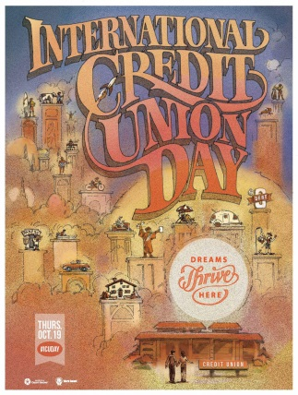](http://www.woccu.org/documents/ICU_Day_2017_Poster-EN)

Loan Rates

New Auto- 2.49% up to 5 years

2.99% up to 6 years

Consolidation Loan- up to $10,000 at 9.99% for up to 5 years

Signature Loan- up to $3,000 at 5% for up to 2 years;

up to $5,000 at 7% for up to 3 years

Used Vehicle- 2.99% up to 4 years

3.49% up to 5 years

Vehicle Exception (older than 2010)- 3.49%- terms to be determined

UALU 354 FEDERAL CREDIT UNION **OFFICE STAFF** Your savings Federally Insured

PO DRAWER I Diane Obitko ⭬ Manager to $250,000

YOUNGWOOD, PA 15697 Jennifer Warrington ⭬ Asst. Mgr  **NCUA**

724 925 9354 or 1 800 344 3540 National Credit Union Administration

a US Government Agency